**File:** **Momchil_Angelov_18_d8aa65.rb**

Task:

Develop a program named FirstName_LastName_ClassNumber_d8aa65.rb

1. you are given two arguments for a folders with files;

1.1 If there are other arguments they should be discarded;

2. Find all the files from both folders that are not in the format FirsrName_LastName_digits.rb. If there are duplicates the file must be written only once.

2.1 If two files are of the same lenght those files should be sorted in ASC order;

3. Calculate the length of their names (including extensions).;

4. Sort the result by lenth ;

5. Produce a result in CSV format named result.csv:

File1,3

File2,4

...

FileN,3

Code:

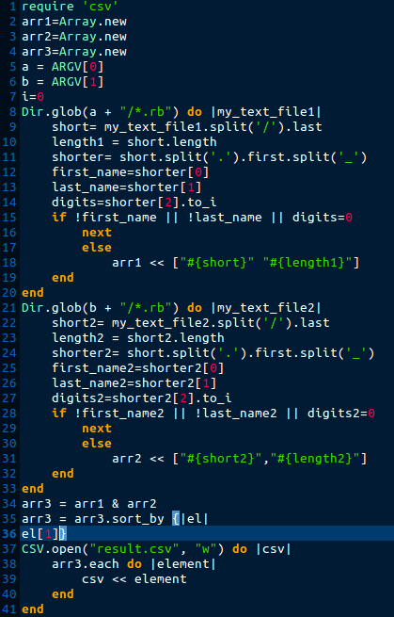

Errors:

* In line 15: warning: found = in conditional, should be ==; digits=0 must be digits==0
* In line 28: warning: found = in conditional, should be == ; digits=0 must be digits==0
* In line 24:in `block in <main>': undefined local variable or method `short' for main:Object (NameError); short must be short2

New code:

